UK MEGA EVENT
Harrogate North Yorkshire
3 AUGUST 2008

The idea for the event started some months ago with a forum post, and it snowballed from there. Many months and about 6000 pounds later the idea came to fruition.
We had been staying at the Cedar Court Hotel from the Friday night till Monday morning, and we were really glad we did as we were able to absorb the total atmosphere from start to finish. On arrival we met up with a couple friends of ours from Cape Town who had moved over here some years ago, we checked in and checked out heading for the nearest cache. Now he does not cache but is about as mad about his photography as we are about chasing plastic containers, so we were happy doing both hobbies together
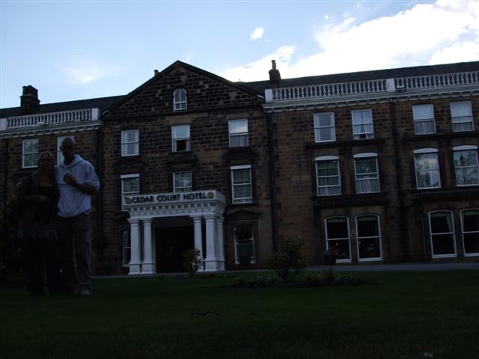
We headed out for Betty’s Bistro a world famous spot for good food and damn fine coffee; if you are ever over there its worth spending those precious Rand’s if you can spare them. Right opposite the Bistro is a micro under a bench which unfortunately went missing and we only found out on the last night that it had been replaced, so we lucked out on that one.
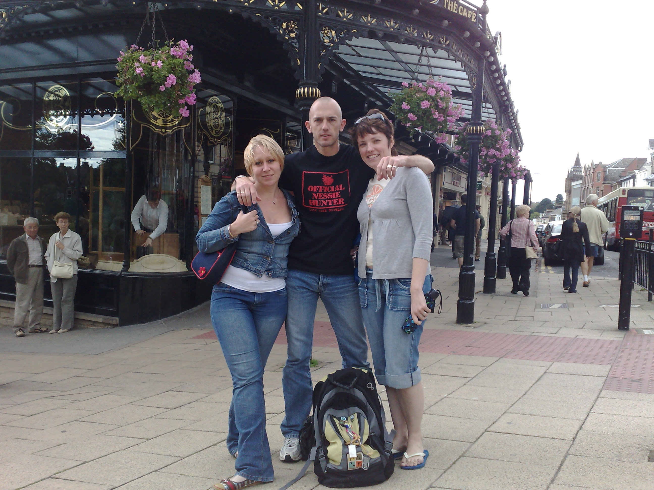
Around Harrogate central there are a few well placed micros which are difficult to obtain for obvious reasons. One bench had a trio of drunks sitting on it and as we were walking around the bench looking and looking in the nearby tree, they became a little concerned that we were trying to take photos of them and in retrospect maybe we should have, they were really funny..
The Friday night they had organized one of several other events to attend, They came from the North GC18ZZE ,so off we went to the pub a few miles away, walked in not knowing a soul there, within 10min we were sitting at a table with complete strangers talking geocaching, sharing stories and I was even sharing a single seat with a elderly gentleman while he was eating his supper. They had a quiz going, raffle tickets selling for some fab prizes. Later on I was trolling the pub holding my collection of coins looking to discover other peoples coins, plenty were abound, so I just went up to them, told them who I was and started chatting, what a way to meet complete strangers. Around 21:00 the pub started emptying and we decided it was time to leave also.
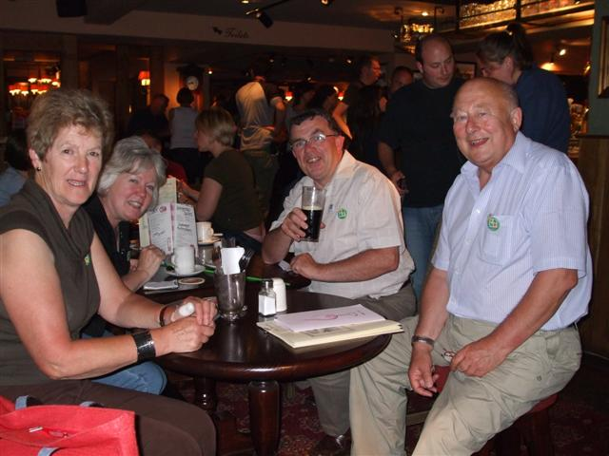
The chap holding the beer was the one whose chair I was sharing
On Saturday the day before the event, my mate and I were up early to catch some photos and a few micros that were difficult to get the day before. Later the morning walking around the city you could pick out the cachers walking around with their friends and families and staring down at their units, and looking at the log entries, some we found had 15 odd entries on them before we got there, so can you imagine the cache owners inboxes after the event weekend. Around 12:00 we took a drive to Knalsburgh a lovely little village just a few miles from Harrogate to take photos and a few caches, which ended up been only one, a micro on a bench in the middle of the town, lucky for me the side where the container was, was free so I just sat down and grabbed it for a easy find. Our friends left back for London and we were left with the whole afternoon with plenty containers to find.
One series that they put out was the Stray series; it’s basically 200 acres of open park that nobody is allowed to build anything on, and that dates back to when Pa fell off the bus. It was a lovely stroll around the park with one lovely cache in particular called Stray cache, in the middle of this massive park there is nothing around you but grass, so where is the cache then, well depending on where your GPS takes you will determine how difficult it can be, what you were looking for was a stop cock cover. Really a great idea I think, now we are not sure whether it is in fact a working one as you cannot see the stop cock(too much mud) or if he dug a hole and placed it there, none the less a good fun cache to find.
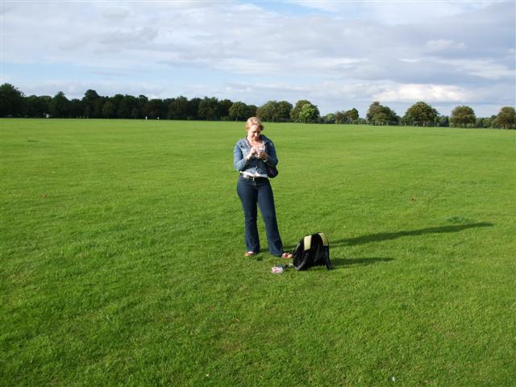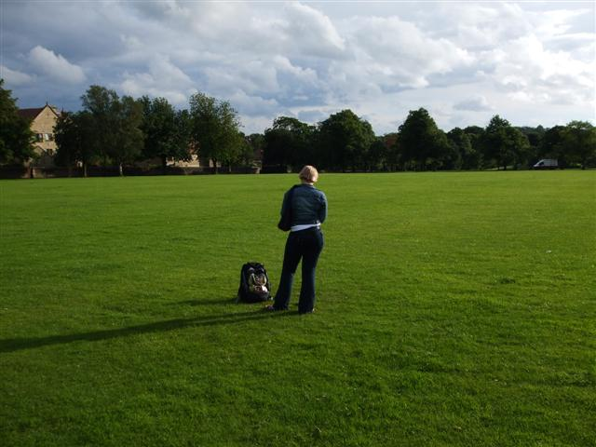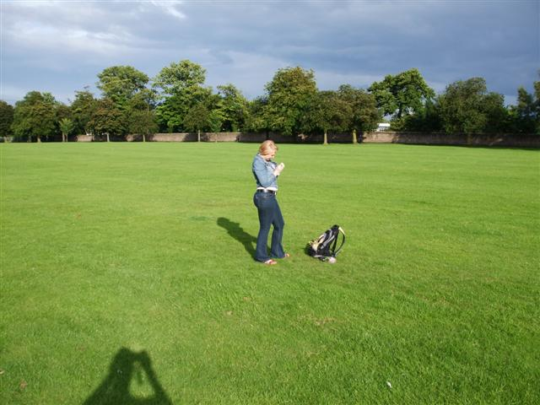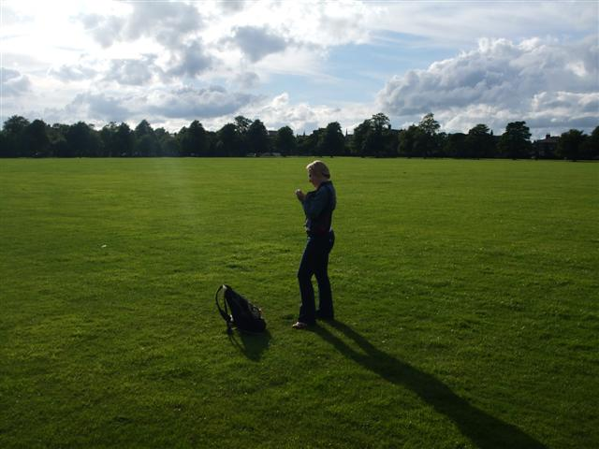
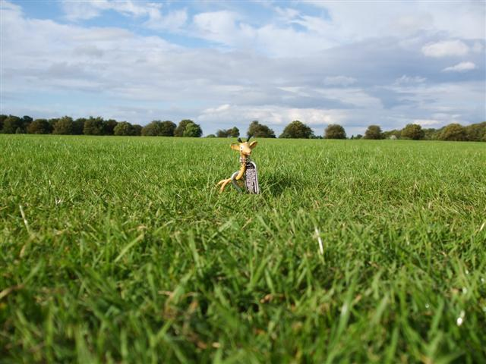
The 4 pictures above were taken in all four directions at the cache and Girry above was standing on top of the cache
Arriving back at the hotel at about 21:30 tired but excited and looking forward to the next day, we relaxed in the lounge with a few drinks and before we knew it we had a mini event in the lounge. One person joined us and within half an hour we had about 10 people sitting chatting. Then this one cacher Slitherin from Austin Texas put’s this piece of rock on the table and looking a bit perplexed I asked. So he says this is a moving cache, what it is, is a piece of Texas Sandstone, with a hole drilled into it and a 35mm film canister inserted into it. How it works, is the person who drops off the cache, publishes the new co-ords in his log for the next person to find. So technically we have now cached in the state of Texas as well. The evening ended for me at about 02:00 in the morning. Great evening was held by all with the remainder of folks going to bed at about 03:00.
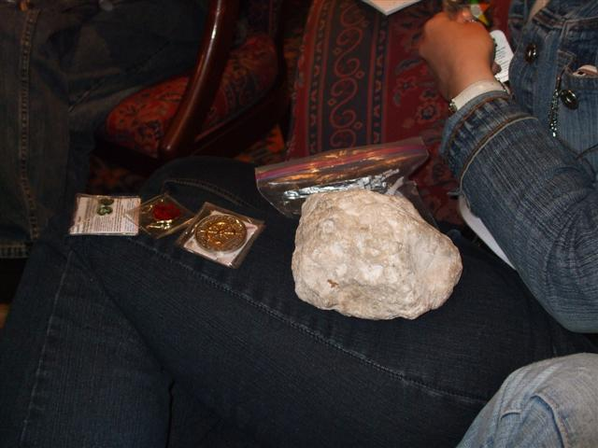
Texas cache
3 August 2008
Waking up at around 07:30 to have an early breakfast I met up with Happyhumphrey from The Isle of Man to do my first Where I Go cache, not knowing what it was all about other than you needed a gps enabled pda or a Colorado I was not sure what to expect. It started out with some instructions on the screen of the pda and off we went across the Stray. When we arrived at the next point it told us to return to the hotel to pick up the pen, I thought this was now a waste of time, but later realized that you have to be within a certain radius for the next set of instructions are released. Walking all along the common it turned out to be fun after all. I was paying so much attention that I did not even realize that we had made it to the end of the cache. Pretty straight forward it turns out but I believe setting them up has a lot more involvement.
By now it was nearing 12:00 the start of the Mega Event. People were milling about and if you had pre registered you could just sign in get your goodie back and enjoy the day. A event coin was minted, gold for attendees and silver for supporters, it turned out there were 50 black coins minted, some of which were for prizes and the rest were for the organizers and I’m sure a few more will find its way into others hands. The event was well organized with a few quizzes that people had to fill in which meant that they had to go up to strangers and talk to them to get the answers which was really great. We ended up meeting plenty new people and that made the day that much better. One of the big happenings of the day was ALL the coins, all shapes, old and new. One chap had 3 folders with over 300 coins some others had leather bound folder with coins. We met with a fellow cacher Russ (the klever boys) who has over 1600 coins.

No he only brought one album.
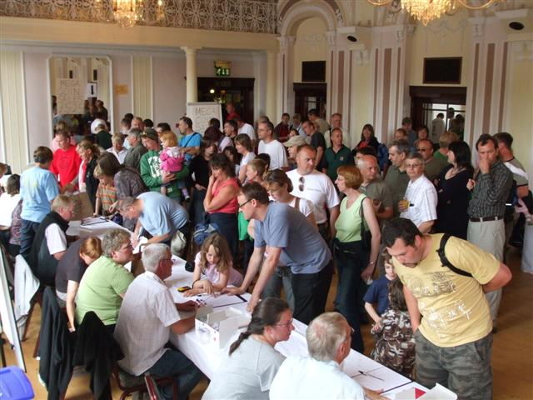
Registration
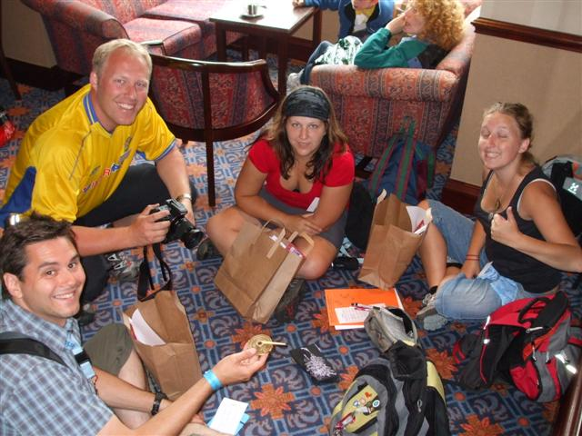
Cachers from Sweden
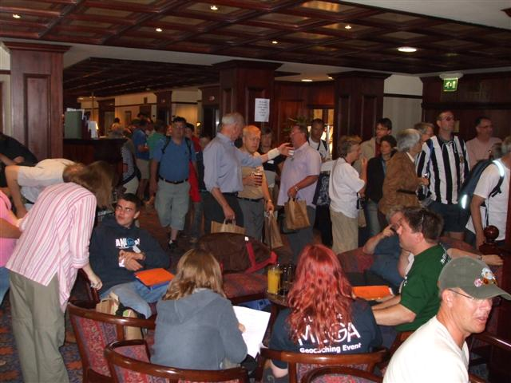
Cachers
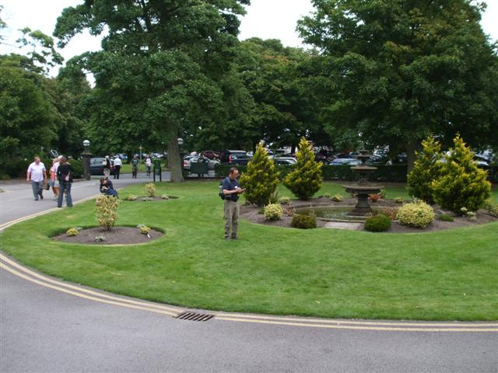
Could he be trying to start the Where I go cache
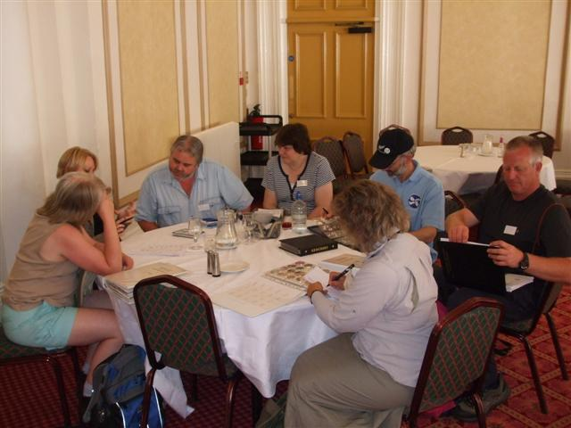
Discovering coins
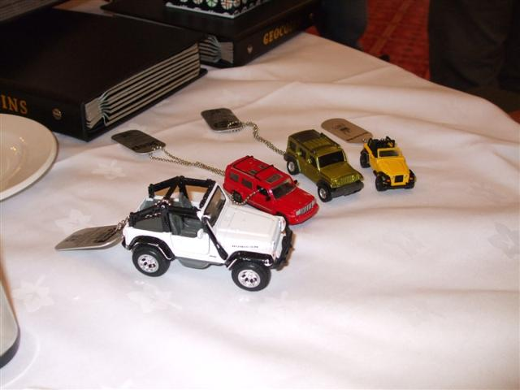
4 of a kind, a rare site
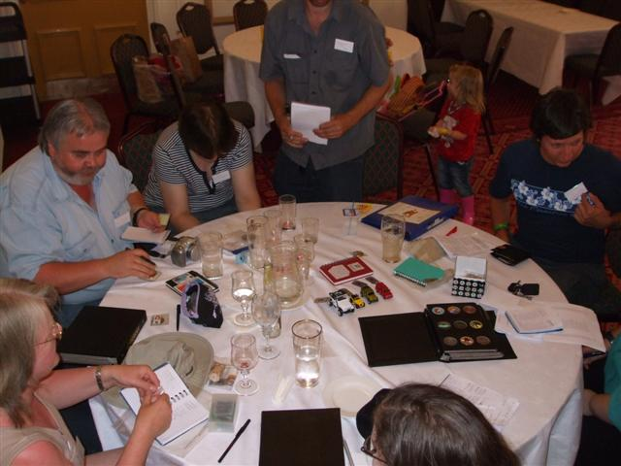
More coins, on the left (blue shirt) is one of The Klever boys about 1600 coins
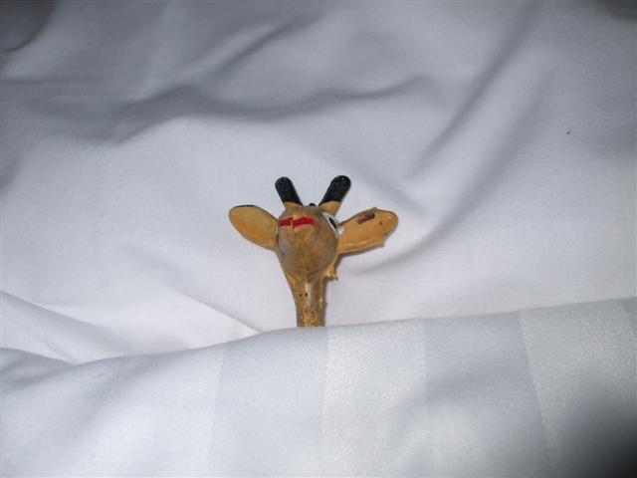
Putting Girry to bed after a long day TBJ4QD
I must say I found all the coins really over whelming I must have discovered close to 500 or so. It would have been really easy to have spent the entire event sitting on my butt looking at all the coins and probably still not see them all. I did drag myself away to mill around chatting to others. They had a few venders there selling their goods which was really nice, as I have see all the stock on the web but seen it on the table makes you appreciate it more. The new Oregon from Garmin was there but as Im not in the market to buy so I did not really fiddle with it.
Throughout the day there were a few raffle prizes with some really lovely prizes and would you believe our name was drawn not once but twice, I could not believe it. So I took a Ground speak lackey coin and a lanyard with several Canadian pins pinned to it. Who would have thought? There were people wearing TB t-shirts walking around. They made a calendar for the event to raise cache, and on the day a surprise to all they had followed the trend of a nude calendar for cancer research, rather funny looking at it but it was for a good cause.
Now the highlight of the day for me was finding and logging the famous Fast Forward - Such den Bulli cache GCKTK0. This is a cache van that moves around and can be tracked in real time, all you have to do is click on the link on its page and it will give you his co-ords at the last position with a map. He has hooked up his gps 5 to his radio transmitter and his co-ords are transmitted continually. Unfortunately for me his van was an easy log as it was parked in the parking lot, I would have loved to find him by tracking him down via the net. A really neat idea, for a cache and what a cool hunt it must be.
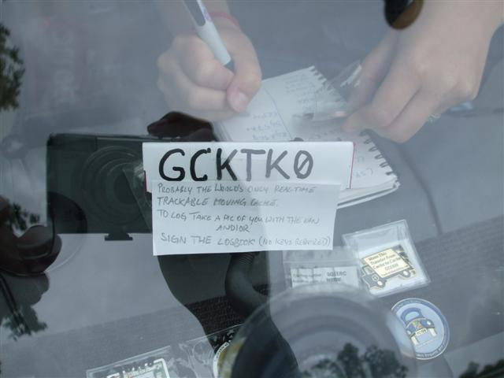
Front wind shield
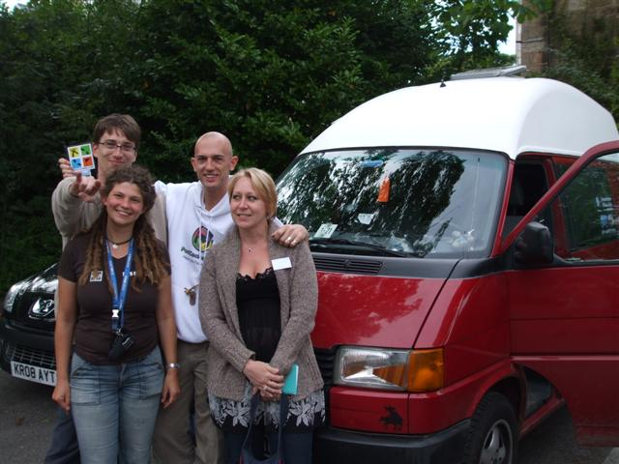
Cache owner and girlfriend
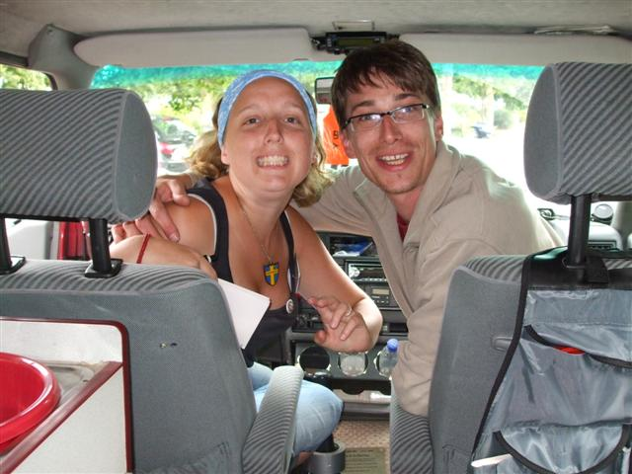
Cache owner on right cacher from Sweden on left
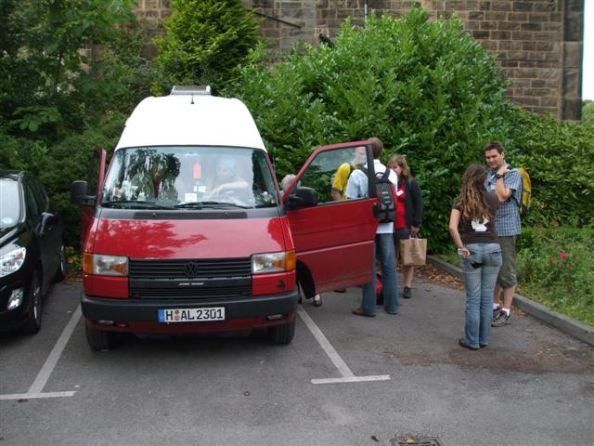
The Bullie
In conclusion I would have to say that it was a splendid if not overwhelming event (depending on how you see it). The people, the noise, the atmosphere was really good, the city of Harrogate was a great place to have it. The experience is great and can recommend it if you ever have the opportunity to attend one, next on our list is the MOGGA or the Geowoodstock events in the states, but not for a year or two at the moment.

